Explain Plan And Analyze
Purpose of Explain Plan is to analyze the execution plan of a query

PLAN_TABLE:

The PLAN_TABLE is automatically created as a global temporary table to hold the output of an EXPLAIN PLAN statement for all users.

PLAN_TABLE is the default sample output table into which the EXPLAIN PLAN statement inserts rows describing execution plans.

While a PLAN_TABLE table is automatically set up for each user, you can use the SQL script utlxplan.sql to manually create a local PLAN_TABLE in your schema. The exact name and location of this script depends on your operating system. On Unix, it is located in the $ORACLE_HOME/rdbms/admin directory.

- PLAN_TABLE is a PUBLIC SYNONYM of SYS.PLAN_TABLE$ Global Temporary Table
- Data of PLAN_TABLE is stored into temporary tablespace segments.
- Data of PLAN_TABLE is private to the session itself, even SYS user cannot query all the contents of PLAN_TABLE.
- Users connected from application or OEM or SQL plus or any other tool will be able to access PLAN_TABLE.

Column List of Plan_Table is as shown below:
Column | Datatype | NULL | Description
STATEMENT_ID | VARCHAR2(30) |  | Optional statement identifier specified in the EXPLAIN PLAN statement
TIMESTAMP | DATE |  | Date and time when the EXPLAIN PLAN statement was issued
REMARKS | VARCHAR2(80) |  | Place for comments that can be added to the steps of the execution plan
OPERATION | VARCHAR2(30) |  | Name of the operation performed at this step
OPTIONS | VARCHAR2(255) |  | Options used for the operation performed at this step; the string returned by the index cost function
OBJECT_NODE | VARCHAR2(128) |  | Name of the database link used to reference the object
OBJECT_OWNER | VARCHAR2(30) |  | Owner of the object
OBJECT_NAME | VARCHAR2(30) |  | Name of the object
OBJECT_INSTANCE | NUMBER(38) |  | Numbered position of the object name in the original SQL statement
OBJECT_TYPE | VARCHAR2(30) |  | Descriptive modifier that further describes the type of object
OPTIMIZER | VARCHAR2(255) |  | Current mode of the optimizer
SEARCH_COLUMNS | NUMBER |  | Number of index columns with start and stop keys (that is, the number of columns with matching predicates)
ID | NUMBER(38) |  | Identification number for this step in the execution plan
PARENT_ID | NUMBER(38) |  | ID of the next step that operates on the results of this step
POSITION | NUMBER(38) |  | Order of processing for steps with the same parent ID. For cost-based optimization, the value in the first row of the plan is the statement's execution cost. For rule-based optimization, the value is null in the first row.
COST | NUMBER(38) |  | Cost of the current operation estimated by the cost-based optimizer (CBO)
CARDINALITY | NUMBER(38) |  | Number of rows returned by the current operation (estimated by the CBO)
BYTES | NUMBER(38) |  | Number of bytes returned by the current operation
OTHER_TAG | VARCHAR2(255) |  | Describes the function of the SQL text in the OTHER column. Values for OTHER_TAG are:  - SERIAL - SQL is the text of a locally-executed, serial query plan. Currently, SQL is not loaded in OTHER for this case.  - SERIAL_FROM_REMOTE - SQL text shown in the OTHER column will be executed at a remote site  - PARALLEL_COMBINED_WITH_PARENT - Parent of this operation is a DFO that performs both operations in the parallel execution plan  - PARALLEL_COMBINED_WITH_CHILD - Child of this operation is a DFO that performs both operations in the parallel execution plan.  - PARALLEL_TO_SERIAL - SQL text shown in the OTHER column is the top-level of the parallel plan.  - PARALLEL_TO_PARALLEL - SQL text shown in the OTHER column is executed and output in parallel  - PARALLEL_FROM_SERIAL - Operation consumes data from a serial operation and outputs it in parallel
PARTITION_START | VARCHAR2(255) |  | Start partition of a range of accessed partitions
PARTITION_STOP | VARCHAR2(255) |  | Stop partition of a range of accessed partitions
PARTITION_ID | NUMBER(38) |  | Step that has computed the pair of values of the PARTITION_START and PARTITION_STOP columns
OTHER | LONG |  | Information about parallel execution slaves and parallel queries
DISTRIBUTION | VARCHAR2(30) |  | Distribution method
CPU_COST | NUMBER(38) |  | User-defined CPU cost
IO_COST | NUMBER(38) |  | User-defined I/O cost
TEMP_SPACE | NUMBER(38) |  | Temporary space usage of the operation (sort or hash-join) as estimated by the optimizer's cost-based approach. For statements that use the rule-based approach, this column is null.
ACCESS_PREDICATES | VARCHAR2(4000) |  | Predicates used to locate rows in an access structure. For example, start or stop predicates for an index range scan.
FILTER_PREDICATES |  | VARCHAR2(4000) | Predicates used to filter rows before producing them
PROJECTION | VARCHAR2(4000) | Expressions produced by the operation
TIME | NUMBER(38) | Elapsed time (in seconds) of the operation as estimated by the optimizer's cost-based approach. For statements that use the rule-based approach, this column is null.

Demo:
Let’s see the execution plan for select Ename, Sal From emp where Sal <= 2000;
Login by Scott account.
First we will see how many rows are there in Plan_Table.
select count(*) from Plan_Table; -- 0
Explain Plan For
select Ename, Sal From emp where Sal <= 2000;

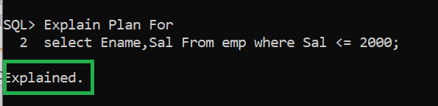

Now we will se how many rows are there in the Plan_table

select count(*) from Plan_Table
/
-- 2

After you have explained the plan, use the DBMS_XPLAN PLSQL Package and its Display function to see the latest plan.

Argument Details of Function Display() of Package DBMS_XPlan are as follows:
Argument Name Type In/Out Default?
------------------------------ ----------------------- ------ ---------------------------------------------------
TABLE_NAME VARCHAR2 IN DEFAULT
STATEMENT_ID VARCHAR2 IN DEFAULT
FORMAT VARCHAR2 IN DEFAULT
FILTER_PREDS VARCHAR2 IN DEFAULT

Table_Name If the default table is not renamed then it is NULL by default.
Statement_ID Statement id of the plan to be displayed. The default value is NULL, which displays the most recent execution plan in the PLAN_TABLE. By this parameter you can have alplaha numeric labelling system for each select / DML statement to be explained.
Format Controls the level of detail displayed, default value 'TYPICAL'. Other values include 'BASIC', 'ALL', 'SERIAL'.

TYPICAL: This is the default. Displays the most relevant information in the plan (operation id, name and option, #rows, #bytes and optimizer cost). Pruning, parallel and predicate information are only displayed when applicable. Excludes only PROJECTION, ALIAS and REMOTE SQL information

SET LINESIZE 130 -- If SQL Plus

EXPLAIN PLAN FOR
SELECT * FROM emp WHERE sal <= 2000;

SELECT PLAN_TABLE_OUTPUT FROM TABLE(DBMS_XPLAN.DISPLAY());
-- Default format to show is Typical

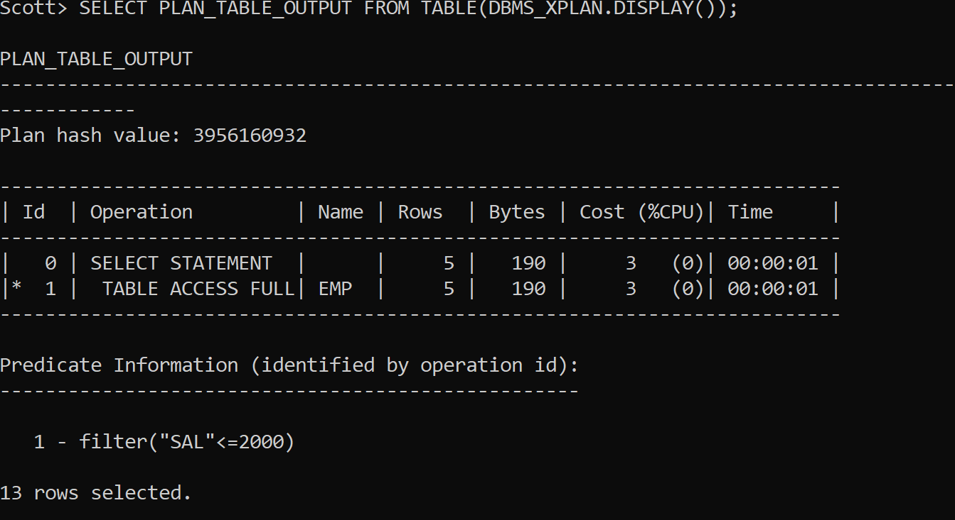

SELECT PLAN_TABLE_OUTPUT FROM TABLE(DBMS_XPLAN.DISPLAY(Format => 'BASIC'));

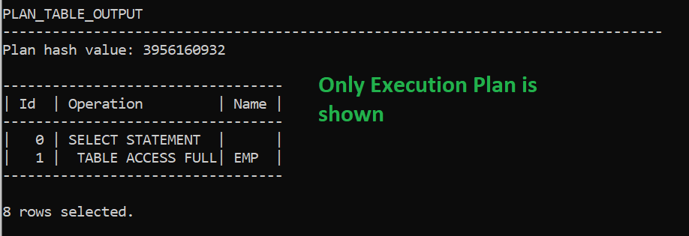

SELECT PLAN_TABLE_OUTPUT FROM TABLE(DBMS_XPLAN.DISPLAY(Format => 'ALL'));
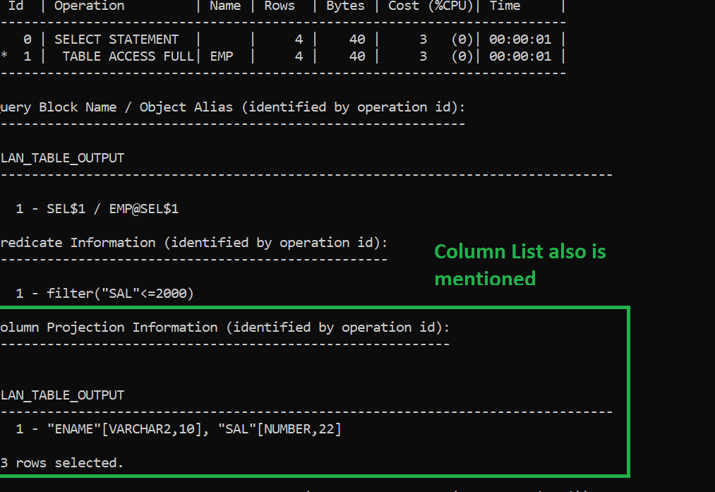

SERIAL: Like TYPICAL except that the parallel information is not displayed, even if the plan executes in parallel.

Examples of Statement_ID
Explain Plan Set Statement_ID = 'ST1'
For
Select Ename,Dname
From Emp Join Dept
On Emp.deptno = Dept.Deptno;

Explain Plan Set Statement_ID = 'ST2'
For
Select Ename,Sal
From Emp
where deptno IN (10, 30);

Now to see the plan of first statement execute the following command;

SELECT PLAN_TABLE_OUTPUT FROM TABLE(DBMS_XPLAN.DISPLAY(Null, 'ST1'));
Note The first parameter is for specifying the Format, i.e.. Typical or Basic or All.

To see the second execute the following command;

SELECT PLAN_TABLE_OUTPUT FROM TABLE(DBMS_XPLAN.DISPLAY(Null, 'ST2'));

